Online Identity Analysis
Megan Jackson
EDU 520: Digitally Mediated Teaching and Learning
Professor Michele Herrera

Online Identity Proposal
Zwilling states, “The internet sees the good, the bad and the ugly” (2015, para. 8). When thinking about one’s online identity it is important to be mindful of this statement. The purpose of this paper is to monitor two individuals to determine what they display in their online identity. By collecting data and evaluating the impact of the individual’s online activity, their online identity will be determined as positive or negative, personal or professional.
Subjects
The two individuals to be observed are Jennifer Serravallo and Lisa Kessler. Jennifer Serravallo is an experienced education professional who started her career as a classroom teacher. Serravallo attended Teachers College at Columbia University while teaching in Brooklyn. She has become a well-known author, known for writing books for educators using reading and writing workshop. Serravallo contributes and works closely with Hienneman publishing as well as Teachers College Reading and Writing Project (TCRWP). She consults schools and speaks at conferences to help teachers with reading and writing. Serravallo is active on multiple social media sites: Twitter, Instagram, and Facebook, as well as having her own website.
Lisa Kessler is currently the music teacher at Sayles School. In her 38th year of teaching she has taken on many roles including technology teacher, teachers league President, and negotiations committee chair. Kessler implements the use of technology whenever it is possible to engage students through a variety of platforms. She encourages students to demonstrate their creativity through music, band, and chorus. Kessler dedicates many hours to the preparation of fun, entertaining performances for students and parents to enjoy. She showcases many talents during her performances to include not only musical talents but dance and theater as well. Kessler actively uses Twitter, Class Dojo, and Linkedin, as well as updating her page on the school website.
Data Plan
The elements to be collected on the two individuals include frequency, platform, content, impact, and collaboration. Collection of data using these elements will identify how often the individual posts, if the individual favors one form of social media over any others, the type of posts (personal or professional), if there is a positive or negative response, and if other people are involved either directly or indirectly with the post. The various platforms that are used by the individuals will be monitored daily to collect the data. A table will be used to collect the data, so it is easy to evaluate the information.
Individual
Date | Platform | Content | Impact | Collaboration | Screenshot

This table will make it easy to evaluate the two individual’s online identity, the impact of their online identity, and to compare the two individuals. By creating a table for each of the individuals using the same elements for data collection it will be fair and consistent. With the use of this table it will be easy to determine if these individuals have a positive, negative, personal, or professional identity.

Data Collection
See the tables below of the data collected over a two-week period of time for both individuals.
Jennifer Serravallo
Date | Platform | Content | Impact | Collaboration | Screenshot
5/12/2019 | Facebook | This post seems to be more personal as it has nothing to do with reading itself | Positive | Sharing a resource | 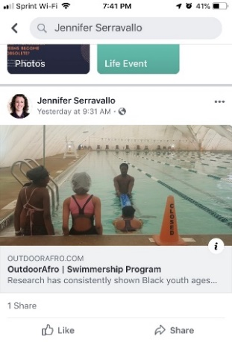
5/11/2019 | Facebook | Professional: This specific article is an open letter in which the author addresses cultural diversity within her own experiences | Positive | Followers like this post, Serravallo is sharing an author’s work. | 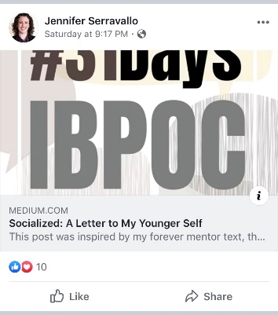
5/7/2019 | Facebook | Professional: The article highlights the importance of poetry but also provides a short biography of the author. | Positive | Many followers shared the post and a few commented having known the authors work. | 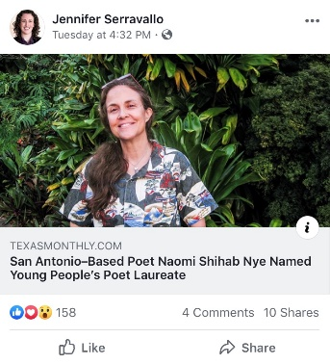
5/5/2019 | Facebook | Professional: A collection of essays written by Indigenous, Black, and People of Color | Positive | Followers shared, liked, and commented on the post regarding the impact of the essays. | 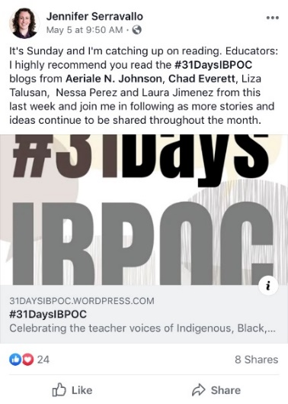
5/5/2019 | Twitter | Professional: A collection of essays written by Indigenous, Black, and People of Color. | Positive | Many followers have retweeted with their own remarks. | 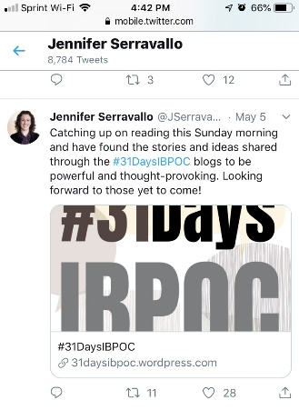
5/7/2019 | Twitter | Professional: Sharing a giveaway for Teacher appreciation | Positive | Retweet | 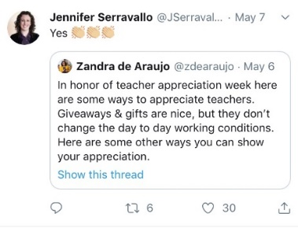
5/13/2019 | Twitter | Personal/Professional: This post is promoting her workshop conference. | Positive | Many commenters remark on having been to one of her conferences in the past or looking forward to a future conference date. | 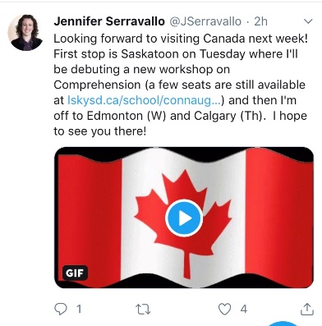

Lisa Kessler
Date | Platform | Content | Impact | Collaboration | Screenshot
2018/2019 school year | School website page | Professional: To inform parents and students | Positive | Occasionally shares events | 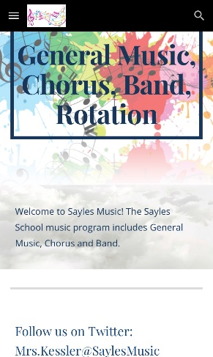
5/1/2019 | ClassDojo | Professional: To inform parents and students | Positive | N/A | 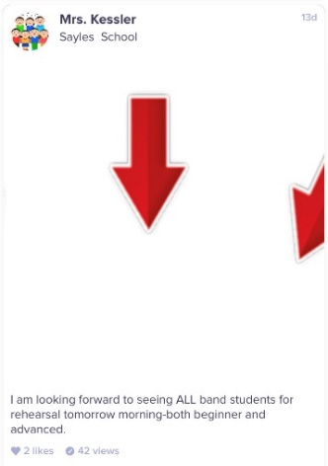
5/7/2019 | ClassDojo | Professional: To inform parents and students | Positive | N/A | 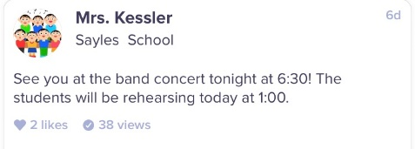
5/8/2019 | ClassDojo | Professional: To inform parents and students | Positive | N/A | 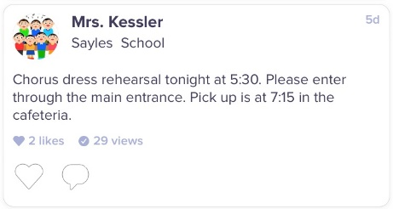
5/10/2019 | ClassDojo | Professional: To congratulate students on their hard work | Positive | N/A | 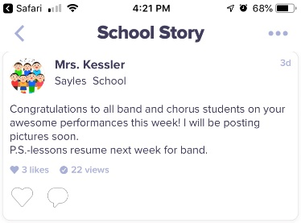
5/13/2019 | ClassDojo | Professional: To share moments of concert with parents and students | Positive | Photos taken by students on yearbook committee. | 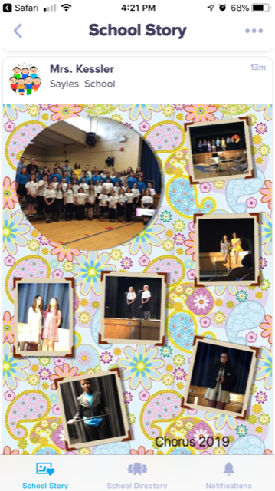
5/13/2019 | ClassDojo | Professional: To share moments of concert with parents and students | Positive | Photos taken by students on yearbook committee | 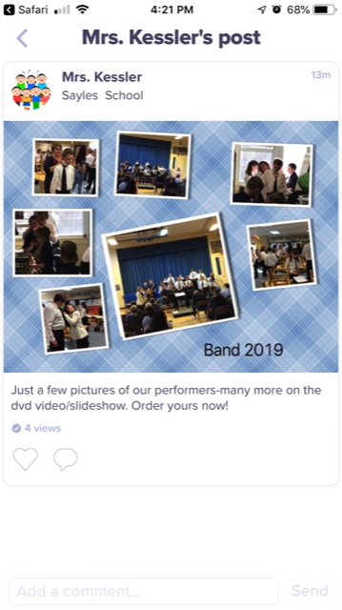

Serravallo Data Analysis
All the data collected for Jennifer Serravallo were based on her posts on Facebook and Twitter. During the data collection period she did not post on Instagram, the last post being a personal picture on April 15, 2019. The data indicates that Serravallo remains professional although she hints at a few personal notes. Serravallo is an advocate of cultural diversity and it is demonstrated through her posts on social media. As is evident in the following post:
On three of the seven posts Serravallo simply shares an article for her followers to read and develop their own opinion on the topic. Of the remaining posts Serravallo simply writes a short statement, never truly voicing her opinion on the matter. The one exception is her post regarding her workshop conferences.
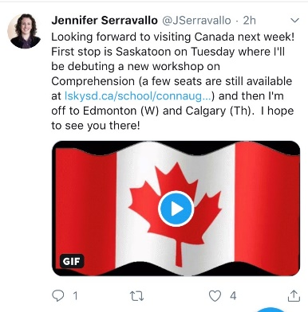
Serravallo is best known for her workshop conferences and her books providing strategies and support for TCRWP workshop. While she is promoting her conferences to her followers she is providing an opportunity for those followers to receive training and professional development to further their understanding of the workshop model. Serravallo does have a website with navigational tabs for biography, publications, speaking calendar, blog, and contact information. Her speaking calendar is up to day, as she has events scheduled into the fall of 2020, her last blog post was dated in 2017. Serravallo’s online presence is professional and effective in that she shares articles, conference information, and experiences with her followers on social media. She could benefit from updating her blog page on her website to add a personalized touch and share her knowledge/experiences with individuals who do not use social media platforms.
Kessler Data Analysis
Findings from observing Lisa Kessler’s digital platforms indicate that she favors ClassDojo. With the understanding that this platform is geared toward educators, parents, and students, it helps one realize the content Kessler posts. Kessler was very active with posts regarding concerts during the observational period, sharing dates and times of rehearsals as well as pictures from the performances. It is important to note that during the two-week period Kessler did not post on LinkedIn or Twitter.
Due to the demographics of Kessler’s intended audience, not all parents/guardians access ClassDojo to stay informed. Many of the parents do not sign up for ClassDojo therefore did not see the post regarding the chorus dress rehearsal date and time. This could have a negative impact however, Kessler’s posts are positive and professional.
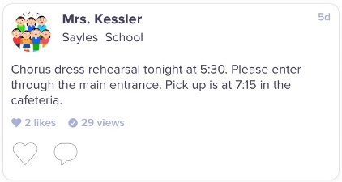
Mrs. Kessler’s school website page is easy to access and helpful for general music, band, and chorus information. She posts grade specific information for students and parents. Kessler includes a link to her Amazon wish list and provides contact information. She even shares local musical events that may be of interest to students and their families. Kessler’s online presence is effective in this school setting and shows professionalism in all posts.
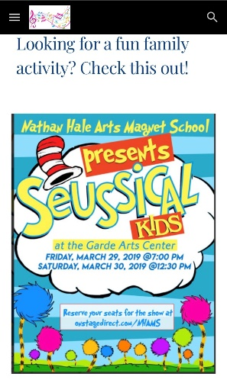
Impact on PLE
A target audience plays an important role in a person’s online presence. Determining who to reach and with which platform are important questions when it comes to online identity. Both individuals discussed in this paper have professional identities but with two different audience types. Serravallo is more of a celebrity online identity with a large audience. Kessler has a smaller audience for her online identity since she is posting from a small rural school setting. Both individuals’ online identities are important and appropriate for their target audience.
While observing these two individuals online I have found that one may determine what to post, share, or write based on the audience being addressed. For instance, Kessler’s posts on ClassDojo are informative since she is addressing parents and students. Serravallo’s posts vary from educational, sharing articles of interest, to posting her travel schedule since her audience consists primarily of educators from around the world who want to gain knowledge. Therefore, both individuals share, post, or write what is relevant to their audiences. While developing my PLE I will need to be mindful that whatever I may share should be relevant to my audience, but first I will need to establish an audience.
Both individuals remained professional and effectively limited voicing their personal opinions online. Seeing as how my PLE will be a professional platform I will always need to limit my opinion and remain professional. Currently I do not post my opinion on any social media, so I feel this will be an easy transition for me. I want my PLE to remain professional and let my audience draw their own conclusions on the topics I share.

Conclusion
Having an online identity makes an important impact on today’s digital society. Addressing the target audience and remining professional can be challenging. Providing information that is relatable to the audience is imperative. Having a professional online identity that positively impacts others is all about sharing knowledge and experiences respectfully. There will likely be positive and negative feedback, how one responds to that is what makes him/her professional.

References
Zwilling, M. (2015). 6 keys to a positive online presence and reputation. Entrepreneur. Retrieved from https://www.entrepreneur.com/article/249053

